**4ITRC2 Operating System Lab**

**Lab Assignment 3**

**Aim:** To create shell scripts for the following questions

**To perform:** To code and solve the following

**To Submit:** Give shell scripts for following:

1. To find Largest of Three Numbers

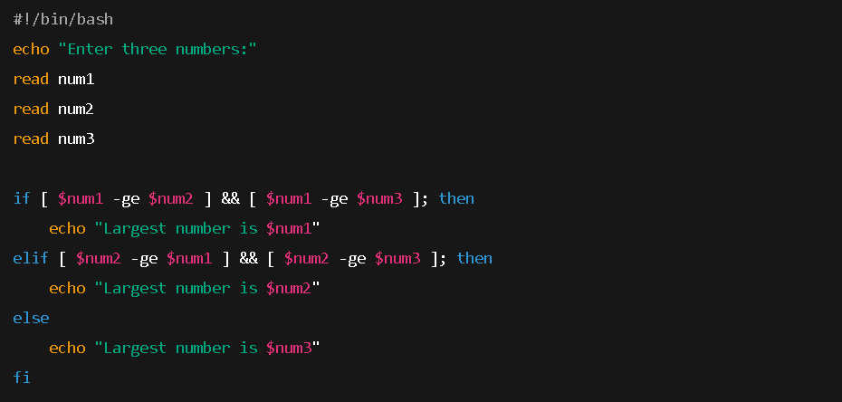

Output:-

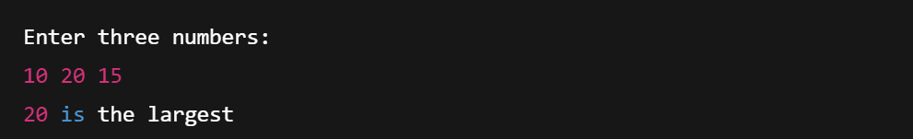

2. To find a year is leap year or not.

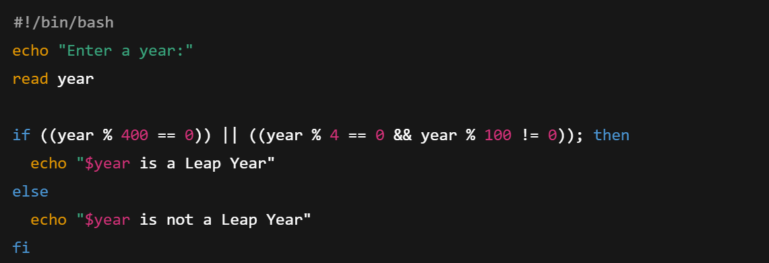

Output:-

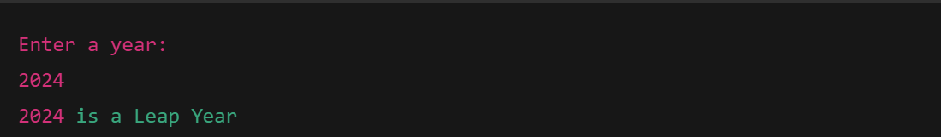

3. To input angles of a triangle and find out whether it is valid triangle or not

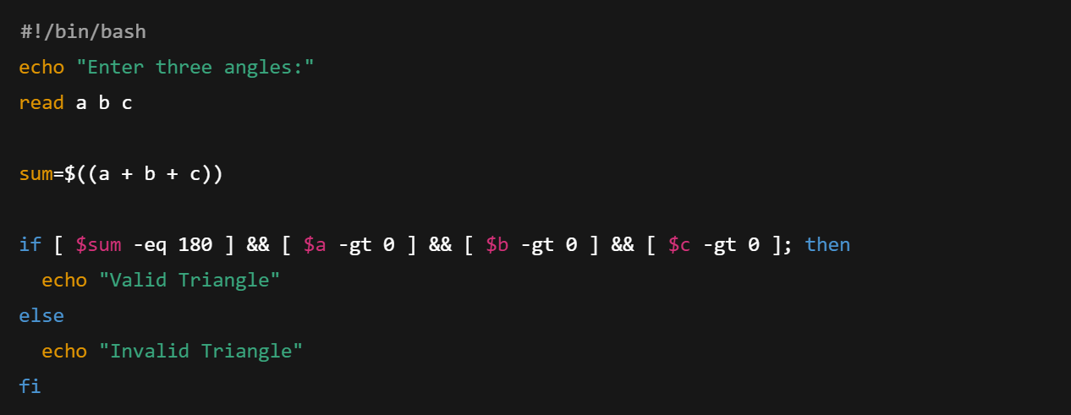

Output:-

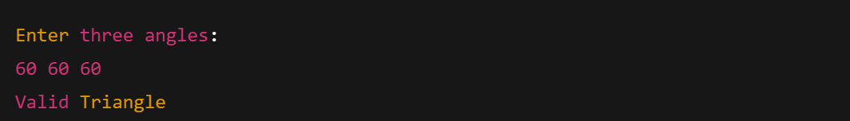

4. To check whether a character is alphabet, digit or special character.

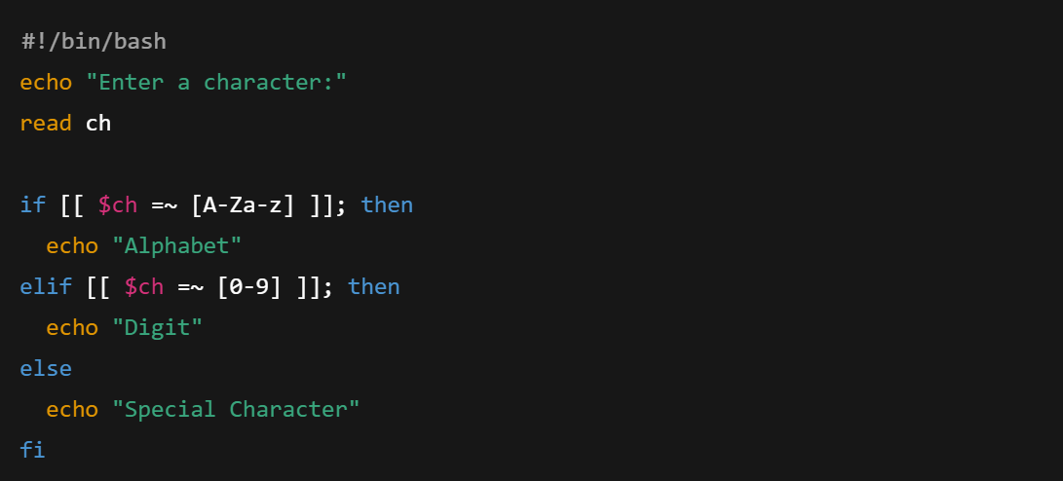

Output:-

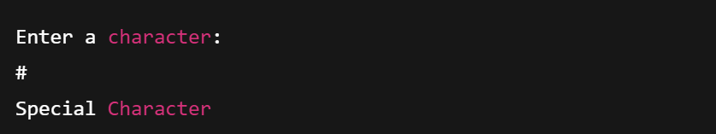

5. To calculate profit or loss

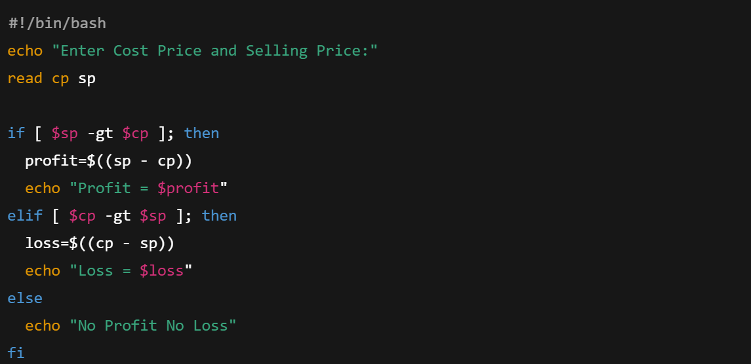

Output:-

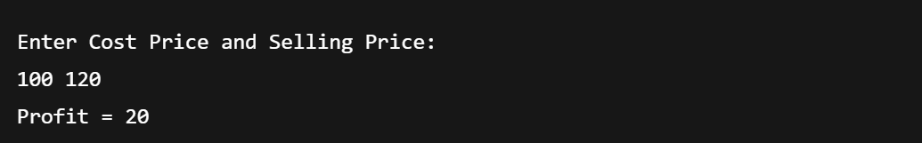

6. To print all even and odd number from 1 to 10

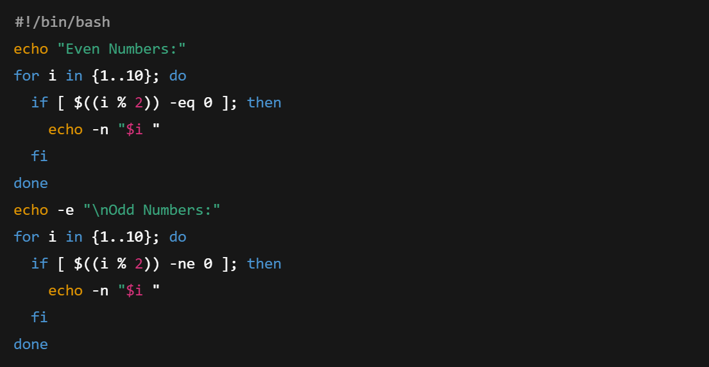

Output:-

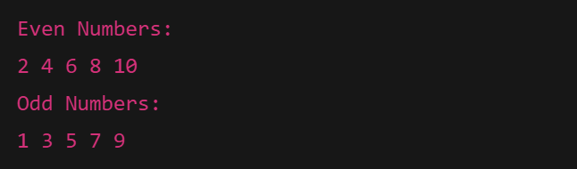

7. To print table of a given number

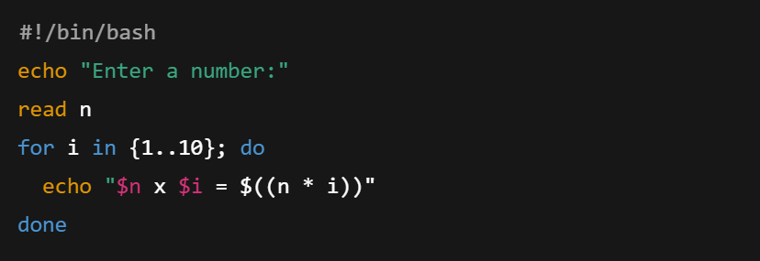

Output:-

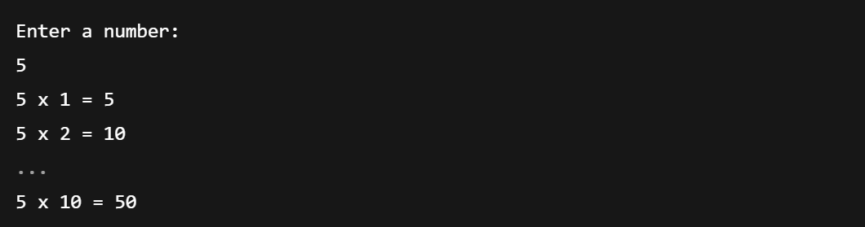

8. To find factorial of a given integer

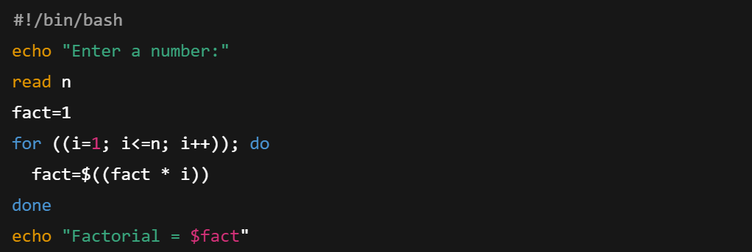

Output:-

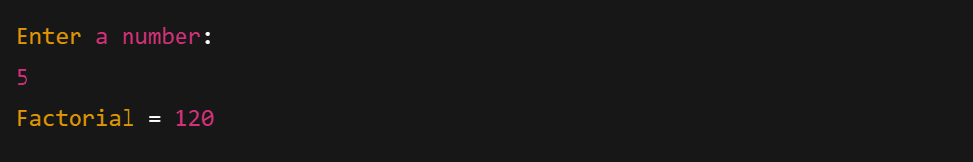

9. To print sum of all even numbers from 1 to 10.

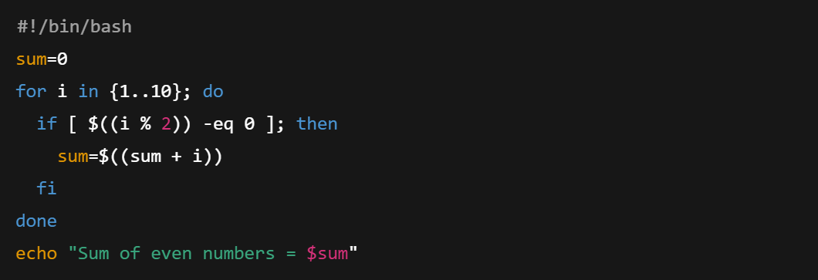

Output:-



10. To print sum of digit of any number.

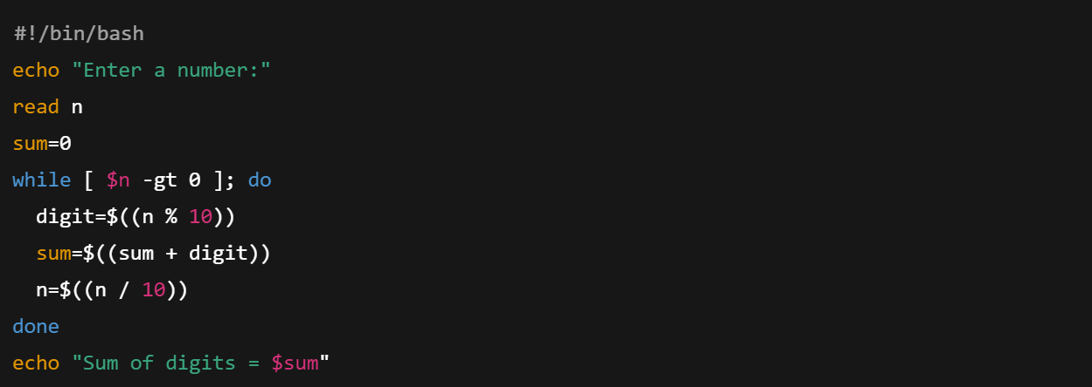

Output:-

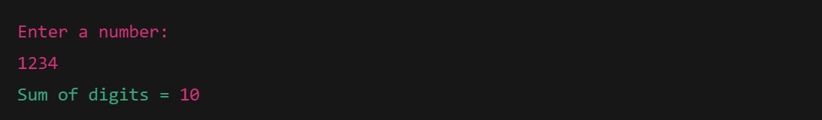

11. To make a basic calculator which performs addition, subtraction, Multiplication, division

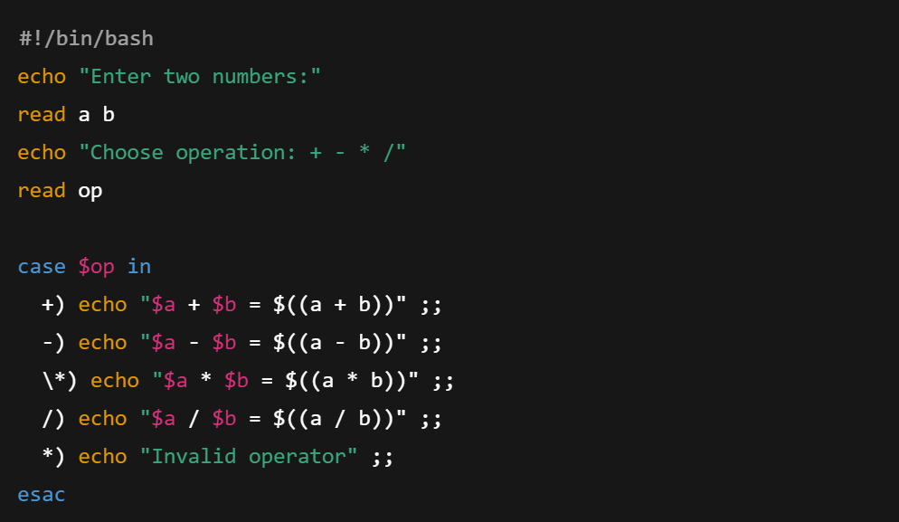

Output:-

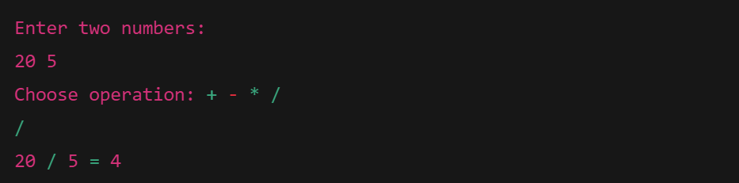

12. To print days of a week.

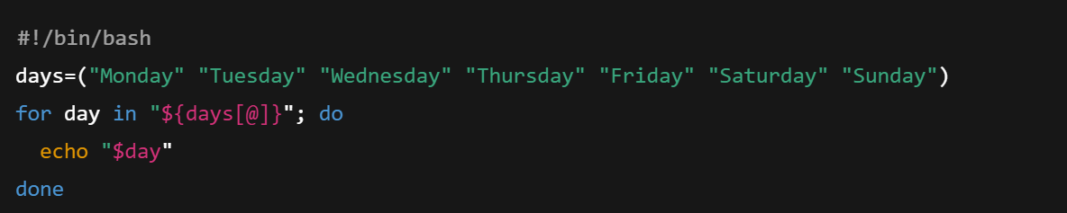

Output:-

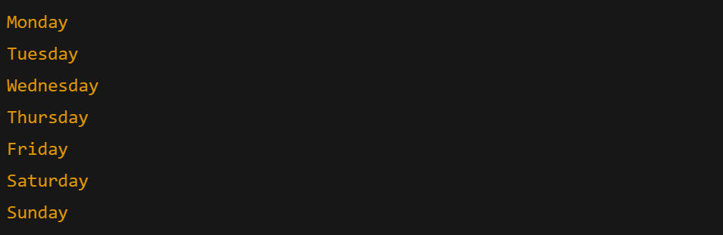

13. To print starting 4 months having 31 days.

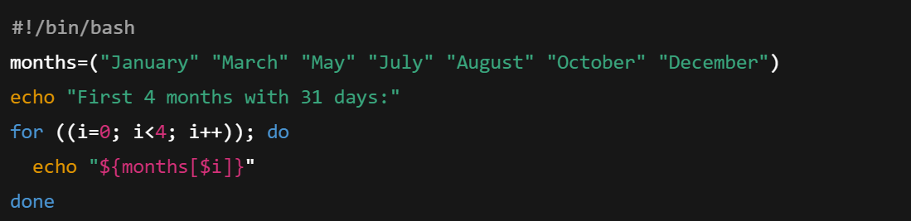

Output:-

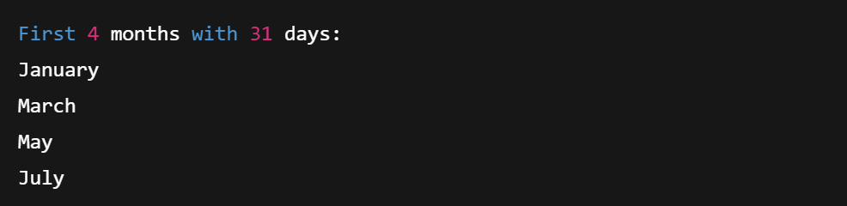

14. Using functions,

a. To find given number is Amstrong number or not

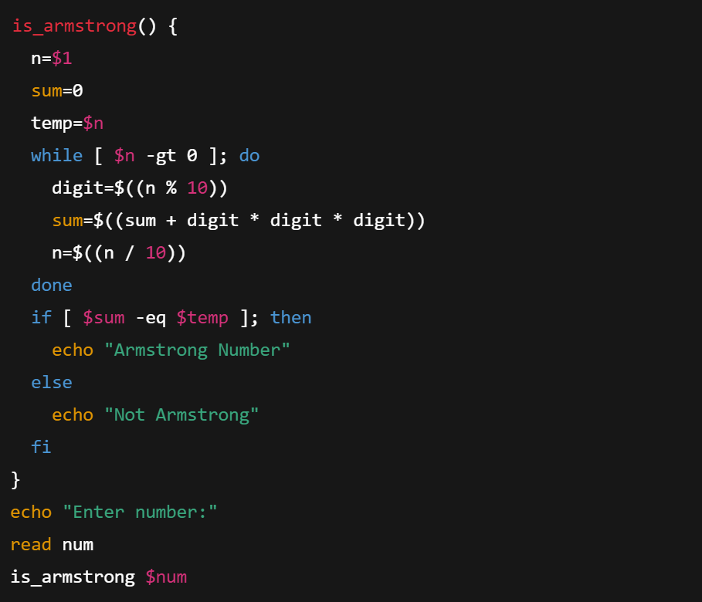

Output:-

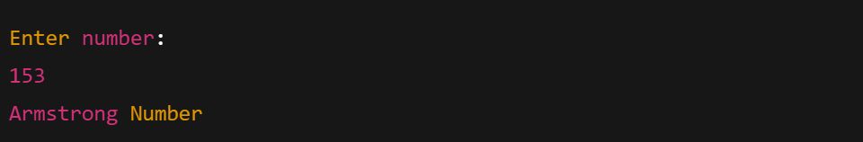

b. To find whether a number is palindrome or not

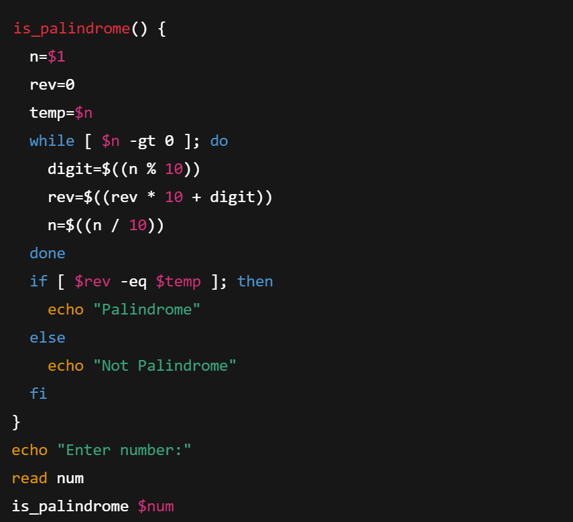

c. To print Fibonacci series upto n terms

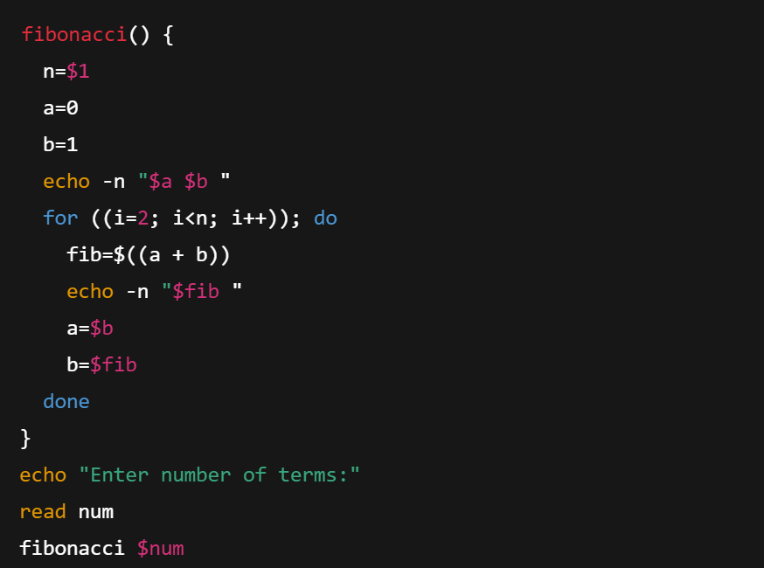

d. To find given number is prime or composite

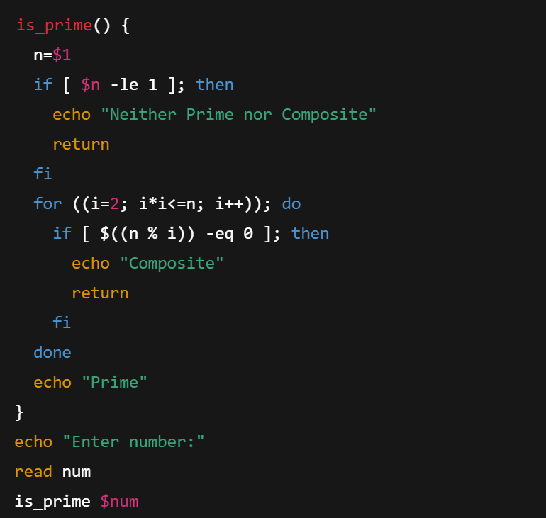

e. To convert a given decimal number to binary equivalent

